Mathsetter
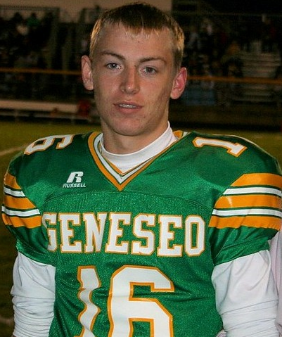

Alex Dichiser
How does it feel to have earned the title Mathsetter?
It’s an honor, but now I don’t get to hear any interesting nominations about myself.
What is the most fun you have had in a Math class?
I would say breaking all of Beeth’s writing utensils last year. That was pretty funny!
Where plan to go to College:
University of Iowa
Do you plan to continue with math (directly or indirectly) in college?
Yes, there is no avoiding it.
Any advice you would give to students who have to have Mr. C for a teacher for two years?
Nope. You’re all doomed.
Any story you would like to share about one of your classmates?
Don’t ever doubt Eric Dellett on a math question. He knows all the answers.
How many times have you laughed in class this year?
Let’s just say I’ve burned more calories laughing in class than I do playing baseball.
Favorite Song:
Like You Ain’t Even Gone by Florida Georgia Line
Person from the past that you would have most liked to meet?
Babe Ruth
Does math come easy to you, or do you have to work at it?
I guess we’ll find out on May 12th.
AP Calculus BC - Is it as intimidating as it sounds?
Even more than it sounds.
Activities Involved in at School:
Baseball, Football
Favorite Movie or Book:
22 Jump Street
Favorite Fictional Character:
Bruce Piotrowski
Best piece of advice you have heard in school?
“Don’t get caught.” – Mom
How was life with a broken arm?
It was life changing. I recommend everyone try it sometime.
What is your 5th LEAST favorite color?
Coquelicot
If you were a janitor, what would be the least fun thing or place to clean?
Your class after a test. They are pretty deadly.
How many times have you dropped your calculator in class?
Believe it or not, only once in two years.
Is there anything else you would like to share?
I locked my keys in my car this past weekend.
Do you have a favorite number?
Any number but e.
Which is your favorite toe?
The one next to the big toe.
Favorite food or place to eat:
Buffalo Wild Wings
Favorite Hobby:
Playing sports with friends

