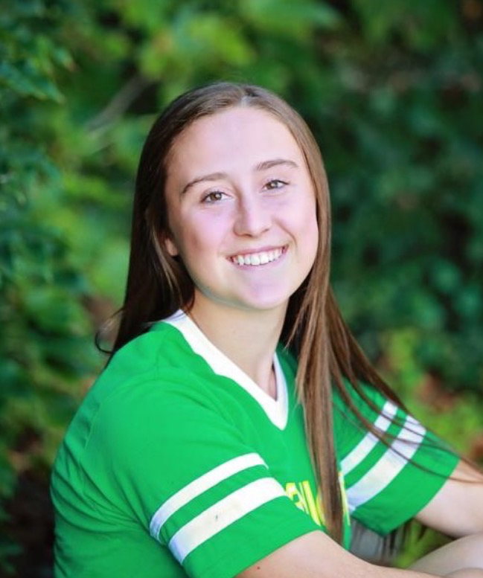
Mathsetter

Tarah Fisher

How does it feel to have earned the title Mathsetter?
I feel extremely honored to have been considered for such an award!
Where plan to go to College:
I’m not decided on a specific college yet since I am still waiting to hear back from scholarships, but I do know that I want to go to a college to study to become a pharmacist and will know where by May 1st.
Do you plan to continue with math (directly or indirectly) in college?
Yes, pharmacy school is heavy in the math and sciences the first few years of college.
Any advice you would give to students who have to have Mr. C for a teacher?
The best advice I can give is to know there will be lots of jokes and try not to drop your calculator!
Any story you would like to share about one of your classmates?
Well although not in my math class this year, there is always the great story of Sommer flipping my desk over in math class while I was still sitting in it last year!
Do you have a favorite number?
Of course, number four will always be my favorite number.
Person from the past that you would have most liked to meet?
Abraham Lincoln
Does math come easy to you, or do you have to work at it?
That definitely depends on the type of math or the specific section, some come easy and others take a lot of studying to fully grasp!
AP Calculus BC - Is it as intimidating as it sounds?
I personally don’t think so, but I also really enjoy math.
What is your favorite joke?
Why did the scarecrow get a promotion?
Because he was “out-standing” in his field
What is your favorite time of the day?
Depends on the season for the actual time, but whenever the sunset is!
Favorite food or place to eat:
Green beans!
Favorite Movie or Book:
Harry Potter, both movies and books!
Favorite Fictional Character:
Unsurprisingly, also Harry Potter!
Best piece of advice you have heard in school?
Join as many activities as possible and enjoy being a kid while you can!
What is your favorite place to do your homework? Why?
In my bed, because I find it the most comfortable and if I was uncomfortable I wouldn’t be able to do it for as long. I mean the homework itself already isn’t going to be fun, so there’s no reason to also be uncomfortable.

What is the most recent search item you have attempted?
Sadly all my recent search items have been for my anatomy homework, and the most recent was the tissue that makes up veins.
How many times have you laughed in class this year?
Way too many to keep track of!
Activities Involved in at School:
Mathletes, Tennis, Basketball, Soccer, National Honor Society, and Chess Club.
What is your favorite song?
I honestly don’t have time to listen to much music, so I don’t have a favorite song.
What is your LEAST favorite color?
Orange
What is the most fun you have had in a Math class?
Watching the TV show Numbers was always fun and interesting!
What is your favorite hobby, why?
Either taking naps or watching movies/Netflix because I like to use my down time to actually try and relax!
How many times have you dropped your calculator in class?
Never during class, but once during math lab.
Which came first the chicken or the egg?
The chicken
How do you think you compare to previous Mathsetters?
Comparison wise it is hard for me to say since the other mathsetters are such an impressive group of people, but I can say I’m quite honored to have been awarded the distinction along side them!
What is your favorite non-perishable food item?
I’m hoping canned green beans are considered non-perishable, cause they’re definitely my favorite.
What is your favorite sport and why?
I would say tennis is probably my favorite sport because it is a fairly relaxed sport, yet it still involves a lot of strategy and hard work. Plus, Putman is one of the best coaches ever and made it super enjoyable all four years!
Is there anything else you would like to share?
Not that I can think of off the top of my head!

