Mathsetter
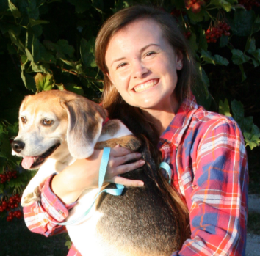

Erin Starkey
How does it feel to have earned the title Mathsetter?
well, i don’t think it’s a bad thing
What is the most fun you have had in a Math class?
idk i just think all math classes are fun
Where plan to go to College, do you plan to continue with math (directly or indirectly)?
Iowa State or Purdue and yes!!!!!! i plan to be an engineer
How many times have you laughed in class this year?
the limit does not exist
Do you have a favorite number?
well on the outside, i say 7….. but on the inside it’s more like 3
What is your favorite song?
“ los pollitos dicen pio pio pio” from spanish class
Person from the past that you would have most liked to meet?
Ghandi
Does math come easy to you, or do you have to work at it?
i mean, i do my homework for the most part, but usually i don’t not understand math
AP Calculus BC - Is it as intimidating as it sounds?
nah you just have to take it day by day
Activities Involved in at School:
tennis, gymnastics, softball (manager?), choir, foreign language club, WYSE, bass fishing club, NHS, scholastic bowl, FCA, TFCA
Favorite Movie or Book:
i don’t really have a favorite movie, and i avoid books like the plague
Favorite Fictional Character:
Chandler Bing
Best piece of advice you have heard in school?
be involved??
Any advice you would give to students who have to have Mr. C for a teacher?
you just have to speak up and tell him what’s up
Favorite food or place to eat:
mexicannnnnnnn
What is your favorite gift you have received or given?
i enjoy a nice hug
What is your favorite hobby, why?
napping……. because it is exhausting putting up with myself all day honestly
What is your favorite sport and why?
tennis because it’s so chill
What is your favorite word in the English language?
hullabaloo
Is there anything else you would like to share?
math just makes me so happy okay thx
What is the most recent search item you have attempted?
dictionary.com
How many times have you dropped your calculator in class?
zero??
Which came first the chicken or the egg?
chicken
What is your favorite non-perishable food item?
easy mac
What is your favorite article of clothing?
sweatpants
What is your favorite equation or formula?
What is your opinion on technology? Good or Bad?
goooooooood
What is your LEAST favorite color?
orange
If you were an alien, what planet do you think you would come from?
well the screensaver on my phone is Jupiter, so i’ll just go with that
Any story you would like to share about one of your classmates?
i don’t think I should go down that road
What is your favorite time of the day?
dawn
What is your favorite kind of weather?
thunderstorms
What is your favorite place to do your homework? Why?
my desk in my room because it’s quiet, and i’m most productive
What is your favorite joke?
i love just about any good pun

