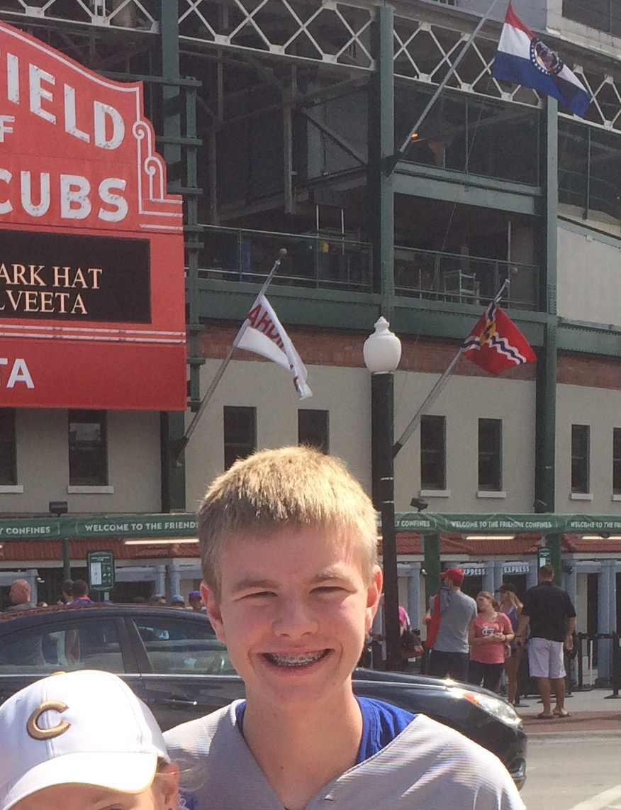
Mathsetter

Dylan Hodge
How does it feel to have earned the title Mathsetter?
The only comparison I have is that it’s like the Cubs winning the World Series divided by 7
What is the most fun you have had in a Math class?
When I beat Mrs. Woolsey at filling out the entire Unit Circle and got the whole class extra credit
Where plan to go to College? Do you plan to continue with math (directly or indirectly) in college?
Iowa State University. Yes, I plan on studying engineering.
Any story you would like to share about one of your classmates?
Alex and I went to a President Trump rally when no one else believed!
With the Cubs winning the World Series, do you have any story or feelings you would like to share?
This is for you Uncle Jim and Cubs fans who have passed!
What is your favorite word in the English language?
“W”
What is your favorite non-perishable food item?
I prefer perishable food
What is your favorite song?
“Sugar” by Robin Schulz
What is your favorite equation or formula?
Person from the past that you would have most liked to meet?
Isaac Newton
What is your favorite kind of weather?
F-5 Tornado
Favorite Movie and/or Book:
Django Unchained
Favorite Fictional Character:
Kane Schultz
Best piece of advice you have heard in school?
“Take AP Calculus BC”
What is your favorite joke?
The St. Louis Cardinals
What is the most recent search item you have attempted?
“Good jokes”
What is your favorite time of the day?
3:14:15
Any advice you would give to students who have to have Mr. C for a teacher?
“Avoid the Walk of Shame!”
What is your favorite hobby, why?
Ping Pong because it’s dabomb
Favorite food or place to eat:
Los Agaves
Is there anything else you would like to share?
Yes

Does math come easy to you, or do you have to work at it?
Is there work involved in math???
How many times have you dropped your calculator in class?
Zero, and I intend to keep it that way
Which came first the chicken or the egg?
The Egg
What is your favorite place to do your homework? Why?
Couch next to ping pong table in front of Cubs Game. I think this situation explains itself
What is your favorite article of clothing?
Cubs 2016 World Series Champion T-Shirt
Do you have a favorite number?
7
How many times have you laughed in class this year?
Every time someone said the Cubs weren’t going to win the World Series
What is your LEAST favorite color?
Cardinal Red
What is your opinion on technology? Good or Bad?
Good
What is your favorite gift you have received or given?
My first Cubs hat
What is your favorite sport and why?
I like watching baseball the most because it is by far the most interesting sport. I like playing tennis the most because I’m good at racket sports.
AP Calculus BC - Is it as intimidating as it sounds?
No
Activities Involved in at School:
Tennis, Scholastic Bowl, WYSE, Mathletes

