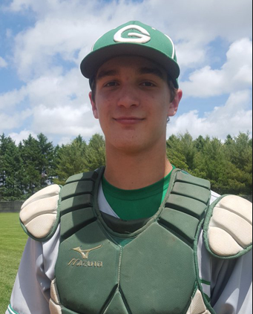
Mathsetter

Keaton Rice
How does it feel to have earned the title Mathsetter? Amazing
Where plan to go to College: Bradley University
Activities Involved in at School: Baseball, Basketball, Men’s Volleyball Club
Do you plan to continue with math in college? I’m sure it will show up
How many times have you laughed in class this year? Too many
What is the most fun you have had in a Math class? Calculus Rhapsody
How many times have you dropped your calculator in class? I dropped Cole’s once
Does math come easy to you, or do you have to work at it? It’s fairly easy
AP Calculus - Is it as intimidating as it sounds? No
Do you have a favorite number? Yes​
What is your favorite song? 21 Guns - Green Day
Person from the past that you would have most liked to meet? Abner Doubleday
Favorite Movie and/or Book: Deadpool
Favorite Fictional Character: Bobby Boucher
Best piece of advice you have heard in school? Do your homework
What is your favorite place to do your homework? Why? Home, it’s nice and quiet
What is the most recent search item you have attempted? What is snowboarding in Spanish?
What is your favorite time of the day? 2:09 p.m.
Any advice you would give to students who have to have Mr. C for a teacher?
Laugh even if it’s not funny
Favorite food or place to eat: Chick-fil-a
What is your favorite hobby, why? Hanging with friends. We always find
something crazy to do.
What is your favorite non-perishable food item? Peanut Butter
What is your favorite equation or formula? a² + b² = c²
What is your opinion on technology? Good or Bad? Wonderful
What is your favorite word in the English language? agelest
What is your favorite kind of weather? Sunny with no wind
What is your favorite gift you have received or given? Christmas Socks
What is your favorite sport and why? Baseball because I like hitting dingers With the Cubs winning the World Series, do you have any story or feelings you would like to share?
Congrats… 8 more to go

What is your LEAST favorite color? Yellow
What is your favorite article of clothing? Socks
Which came first the chicken or the egg? Yes
Any story you would like to share about one of your classmates? No
Is there anything else you would like to share? No

