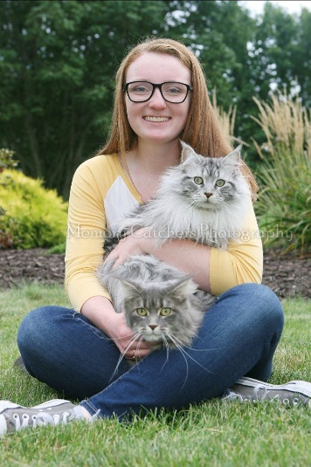
Mathsetter

Madi Miller
How does it feel to have earned the title Mathsetter?
It’s pretty awesome to have my name and picture up on that board with the most prestigious of all
math students.
What is the most fun you have had in a Math class?
Fun? In Math class? What’s that?
Where plan to go to College:
Luther College in Decorah, Iowa
Activities Involved in at School:
Madrigal, Jazz Choir, Tennis, SLAP, Crochet Club, Link Crew
What is your opinion on technology? Good or Bad?
I guess it’s pretty cool, but people are waaaaaay too addicted.
How many times have you laughed in class this year?
Enough times to annoy my classmates
What is your favorite song?
The Quadratic Formula Song is definitely at the top of my list.
Person from the past that you would have most liked to meet?
Beethoven because that dude was TALENTED
Does math come easy to you, or do you have to work at it?
Math is relatively easy for me, but I always have to do my homework or else I’ll forget how to math.
AP Calculus BC - Is it as intimidating as it sounds?
Honestly, I thought Advanced Pre Calc was harder!
Favorite Movie and/or Book:
Anything Harry Potter
Favorite Fictional Character:
Celaena Sardothien from Throne of Glass
Best piece of advice you have heard in school?
“Trying your hardest isn’t good enough” Anonymous Teacher
What is your preferred method of tying your shoes?
The Two Loop Method is superior to all other methods, especially when double knotted.
If you could be a superhero, who would it be and why?
I would be Violet from the Incredibles. Who wouldn’t want to be invisible with a family of superheroes?
If you could choose, which decade would you like to have been born in?
I like being born in 1999 because that way I’m technically from the 90s but can also relate to the 2000s
What is your favorite article of clothing?
My coziest sweatshirt
What is your favorite hobby, why?
Playing piano because it’s stress relieving.
If you were an alien, what planet do you think you would come from?
Pretty sure I’d be from Earth. I hear those aliens are really weird.
What is your favorite kind of weather?
Cloudy, rainy days are the best.

What is your favorite joke?
Knock knock. Who’s there? Banana. Banana who?
Knock knock. Who’s there? Banana. Banana who?
Knock knock. Who’s there? Orange. Orange who? Orange you glad I didn’t say banana!
What is your favorite time of the day?
The best part of the day is any time I’m sleeping.
Any advice you would give to students who have to have Mr. C for a teacher?
Watch out, he’ll cuss at you! (There has only been one recognized instance of cussing so this is probably bad advice).
Any story you would like to share about one of your classmates?
Not that I can think of, but Katie Christensen and Rebecca Clementz are pretty cool.
Favorite food or place to eat:
Los Ranchitos
What is your LEAST favorite color?
Orange
Do you have a favorite number?
17
What is the most recent search item you have attempted?
The Quadratic Formula Song
Do you plan to continue with math (directly or indirectly) in college?
Sorry, Mr. C. No math for me! Just kidding, I’ll probably take a class or two if it’s required.
How many times have you dropped your calculator in class?
I think only once...
Which came first the chicken or the egg?
I think the chicken came first because I hate eggs.
What is your favorite non-perishable food item?
Beans
What is your favorite equation or formula?
The Fundamental Theorem of Calculus is the best because it’s so important!
What is your favorite word in the English language?
“The” is my favorite word because it’s so versatile.
What is your favorite gift you have received or given?
Money
What is your favorite place to do your homework? Why?
The dinner table is the best place so I can actually fit my textbook AND my notebook in front of me (unlike on the wimpy desks at school).
Is there anything else you would like to share?
Not that I can think of

