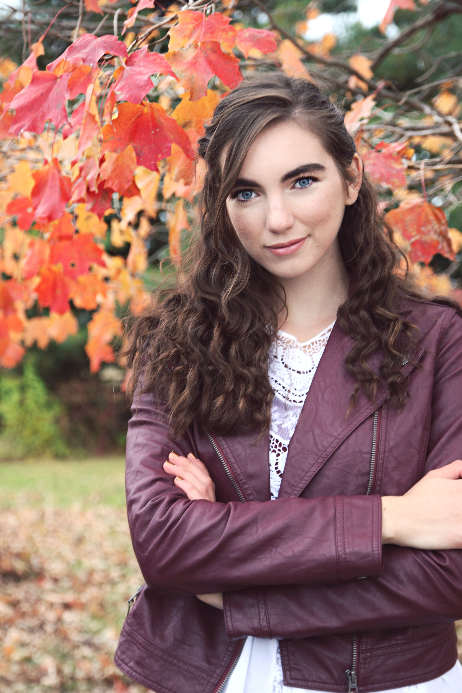
Mathsetter

Anna McVay
How does it feel to have earned the title Mathsetter?
I feel accomplished...and I’m probably much prouder than I should be.
What is the most fun you have had in a Math class?
I can’t think of a specific example, but it probably involves talking with my friends when I should be
working on my math homework.
Where plan to go to College:
Right now, my favorites are Iowa State University, Goshen College, or possibly Starfleet Academy.
Do you plan to continue with math (directly or indirectly) in college?
I’ll probably end up taking more calculus. I don’t think it’s required for my major but i’m curious.
How many times have you laughed in class this year?
A LOT!
What is your favorite song?
I would never be able to choose a single song, but recently I’ve been addicted to a musical/collection of songs called Songs for a New World by Jason R. Brown. I can’t stop listening to it!
Does math come easy to you, or do you have to work at it?
I’ve always been pretty good at math. It comes easily for the most part…except for limits.
I mess those up all the time.
AP Calculus BC - Is it as intimidating as it sounds?
I thought Adv. Pre-Calc was much harder than calculus, so no.
Activities Involved in at School:
Basically everything musical, as well as student council and some theatre stuff.
Favorite Movie and/or Book: Favorite Fictional Character:
The Name of the Wind by Patrick Rothfuss READ IT!!!!! Kvothe
What is your favorite place to do your homework? Why?
My living room because we have huge windows which provide a lot of natural light.
What is your favorite joke?
Two chemists walk into a bar. The first chemist says, “I’ll have some H2O.” The second says “I’ll have some H2O, too.” The second dies.
What is your favorite time of the day?
Early afternoon because it’s always light out.
Any advice you would give to students who have to have Mr. C for a teacher?
Don’t be afraid to ask questions. Mr. C will ALWAYS answer them.
Favorite food or place to eat:
Indian food
What is your LEAST favorite color?
The one with the extraneous “u” in it.
What is your favorite hobby, why?
Developing my skills of sarcasm. Do I really need a reason?
How many times have you dropped your calculator in class?
3… I think
Which came first the chicken or the egg?
Well, even dinosaurs hatched from eggs, so...
What is your favorite non-perishable food item?
NUTELLA!!!!! Yum.
What is your favorite article of clothing?
Definitely my fleece jacket because I am perpetually cold.
What is your favorite equation or formula?
I’m pretty fond of the quotient rule, because you can sing it to the tune of “Master of the House” from Les Misérables: “Low times d of high/less high times d of low/draw a line and put the square of low be-low!”
What is your opinion on technology? Good or Bad?
Good. Well, until the robot uprising, anyway. Then bad.
What is your favorite word in the English language?
Confabulation. It’s just fun to say.
What is your favorite kind of weather?
73 degrees and sunny but with a slight breeze.
What is your favorite gift you have received or given?
I have a cello that was painted on one side for a fundraiser but my private lessons teacher painted the rest of the sides and put one of my favorite book characters on the back. It is by far my favorite gift.
If you were an alien, what planet do you think you would come from?
A cool one hopefully.
What is your preferred method of tying your shoes?
I prefer shoes that I don’t have to tie.
If you could choose, which decade would you like to have been born in?
The late 70s so that I could go through high school and college in the 90s
Person from the past that you would have most liked to meet?
There are too many options. Maybe George Washington.
Do you have a favorite number?
7 or maybe 3.
What is the most recent search item you have attempted?
How to change an M4A file to an MP3. It was for a music audition.

