Mathsetter
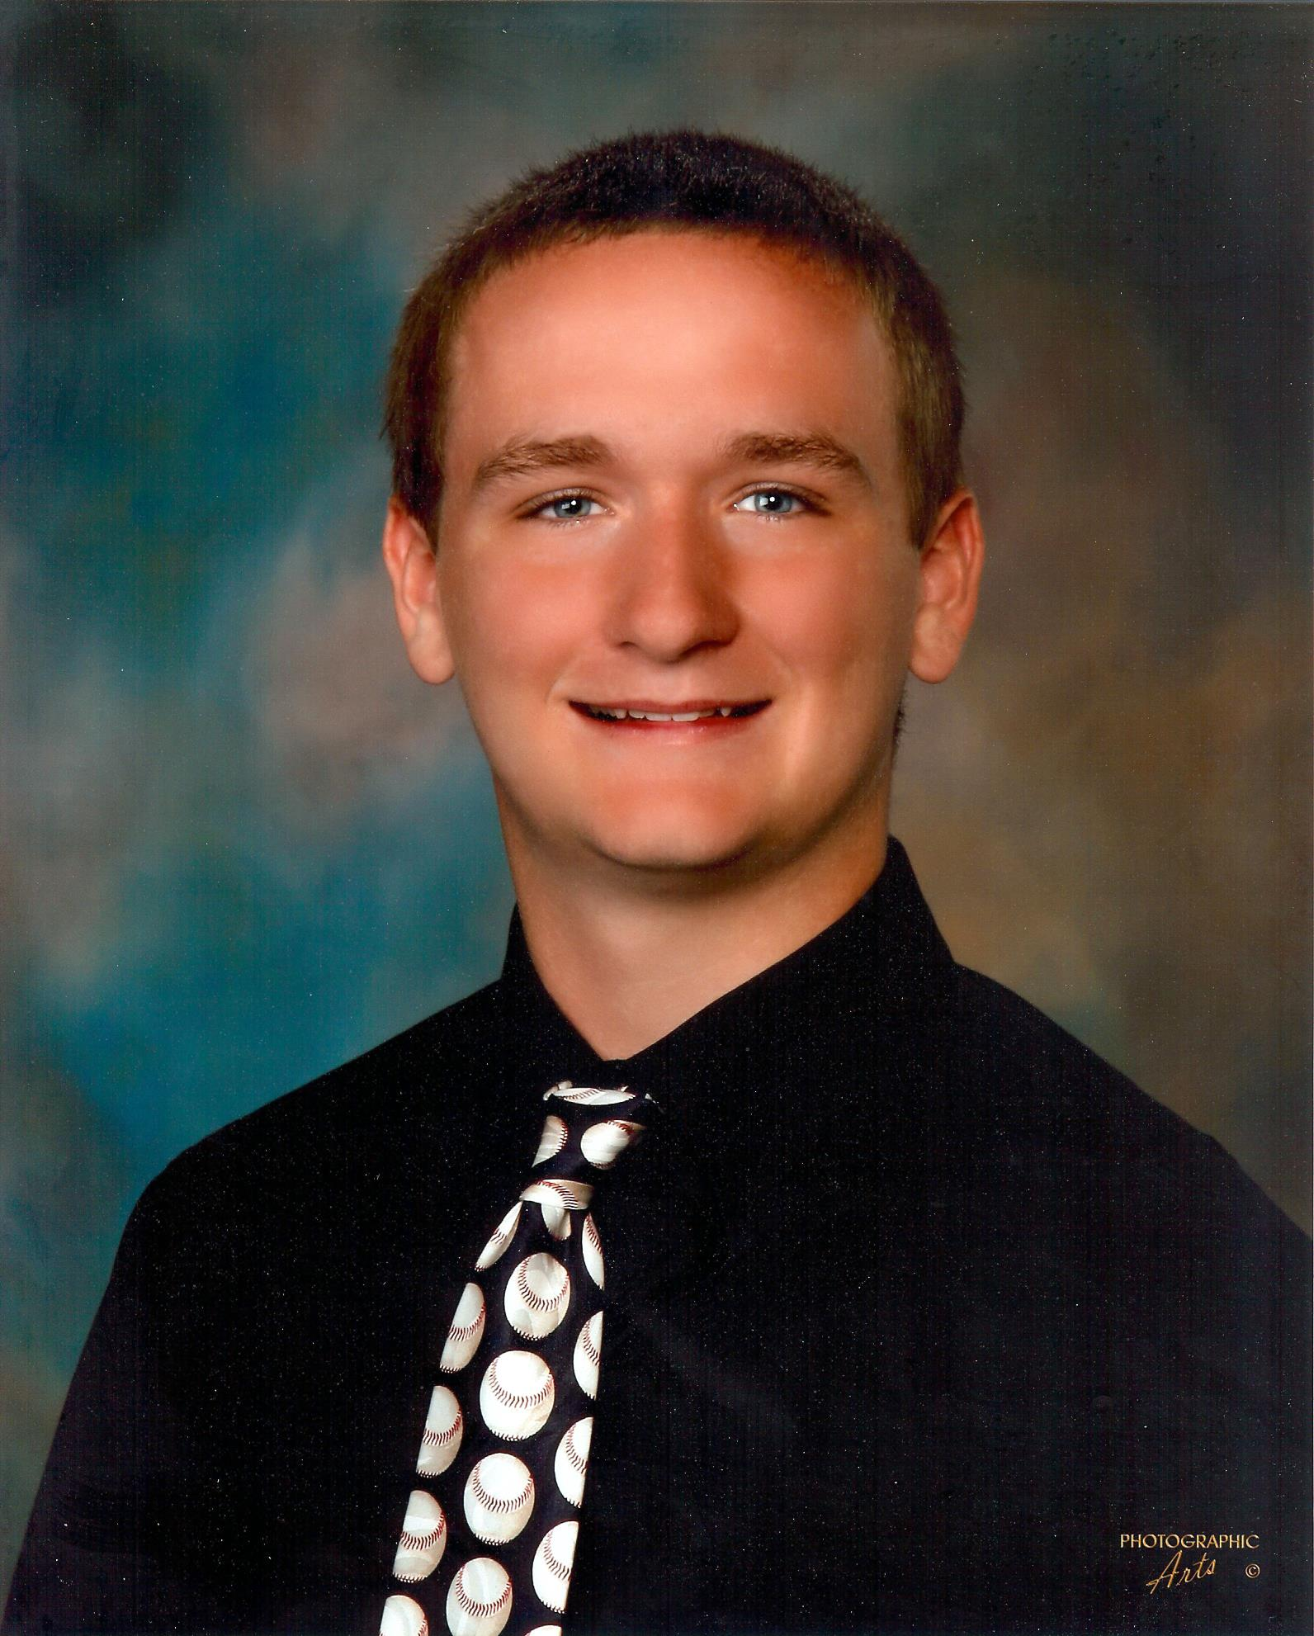

Alex Christensen

What is the first thing that comes to mind knowing you are the first recipient of the 2014/2015 prestigious Mathsetter Award?
That I have to answer a lot of questions

Does math come easy to you, or do you have to work at it?
Math is hard, really hard, really really hard. It’s hard

What is the most fun you have had in a Math class?
Math is a no fun environment

AP Calculus BC – Is it as intimidating as it sounds?
No, it’s even harder

Any story you would like to share about one of your classmates?
Dish moved from sitting in the front of class to the back of class

Favorite Song:
Whatever I can annoy my dad with

Favorite Movie or Book:
Books Suck

Favorite Fictional Character:
Barack Obama

You could have built up quite a collection of stickers. Why don’t you keep them?
Eric beat me and took them from me

You are usually the first one done with a test or quiz, yet you wait till others turn it in first, why?
Because I don’t want to show everyone up

How many times have you dropped your calculator in class?
Zero, I actually care about my expensive calculator unlike others

Do you have a favorite number?
Yes

Favorite Hobby:
Polo (not water polo)

Favorite food or place to eat:
Red Lobster

Activities Involved in at School:
Men’s swimming

Which is your favorite toe?
That’s a dumb question

Is there anything else you would like to share?
N/A

Best piece of advice you have heard in school?
The nonexistent piece of advice

What is your 5th LEAST favorite color?
I don’t have to answer the question I came up with

If you were a janitor, what would be the least fun thing or place to clean?
I would quit

Any advice you would give to students who have to have Mr. C for a teacher for two years?
If you really care for my advice come ask me in person then I will not give you any advice

Do you have any comments about your father being your teacher?
Sure

