Mathsetter
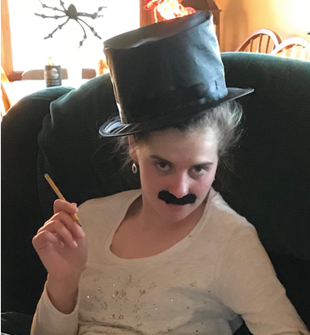

Kylee Gehl
How does it feel to have earned the title Mathsetter?
Unexpected (but appreciated) honor
What is the most fun you have had in a Math class?
Listening to witty comments
Where plan to go to College:
University of Minnesota or Wisconsin
Do you plan to continue with math (directly or indirectly) in college?
Indirectly through environmental science
How many times have you laughed in class this year?
At LEAST 8
Do you have a favorite number?
24601
What is your favorite song?
Music of the Night by Andrew Lloyd Webber
Person from the past that you would have most liked to meet?
Elvis
Does math come easy to you, or do you have to work at it?
Moderate amount of effort
AP Calculus - Is it as intimidating as it sounds?
No, just do the homework
Activities Involved in at School:
Madrigal, choir, jazz choir, spring musical, key club, student council, link crew, SLAP
Favorite Movie and/or Book:
Movie V for Vendetta, Book All the Light We Cannot See
Favorite Fictional Character:
Elizabeth Bennet
Best piece of advice you have heard in school?
Success is the side-effect, not the goal
What is your favorite place to do your homework? Why?
Kitchen counter; no distractions, uncomfortable locale matches the activity
If you could be a super hero, who would it be and why?
Thor; classy and e l e c t r i c
Any advice you would give to students who have to have Mr. C for a teacher?
If you think he’s joking, he’s probably not.
If you could choose, which decade would you like to have been born in?
1920s
Favorite food or place to eat:
Home-cooked meal with family
What is your LEAST favorite color?
Construction orange
What is your favorite article of clothing?
Flannel pajama pants
How many times have you dropped your calculator in class?
2+ this year alone

What is your favorite time of the day?
7pm
Which came first the chicken or the egg?
Egg
What is your favorite non-perishable food item?
Refried beans
What is your favorite equation or formula?
What is your opinion on technology? Good or Bad?
Bad (in excess)
What is your favorite word in the English language?
Umbra
What is the most recent search item you have attempted?
Most recent internet search? Audrey Hepburn quotes
What is your favorite kind of weather?
Thunderstorms
What is your favorite gift you have received or given?
Kitten
If you were an alien, what planet do you think you would come from?
Venus
What is your preferred method of tying your shoes?
Two loops
What is your favorite hobby, why?
Collecting old sheet music; connection to a different time
Any story you would like to share about one of your classmates?
Not at the moment
Is there anything else you would like to share?
Nada
What is your favorite joke?
N/A

