Mathsetter

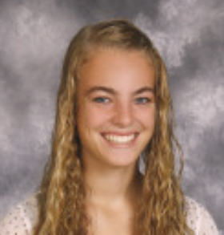

Darci Dietrich

What is the first thing that comes to mind knowing you are the first recipient of the VERY prestigious Mathsetter Award?
Awesome, this could be even better than pacesetter :) Trendsetting isn't a thing I have
done before...sweet.
Does math come easy to you, or do you have to work at it?
Most of the time math comes pretty easy to me, but there are definitely things that I still
have to work on.
What is the most fun you have has in a Math class?
The epiphany moment when things finally click, especially when this happens with
Abby-son or Sarah.
Do you plan to continue with math (directly or indirectly) in college?
Yes, with mechanical engineering I will have just a few more math classes to take.
AP Calculus BC – Is it as intimidating as it sounds?
Definitely no. BC is without a doubt my favorite class. Sometimes it gets a little bit mind
boggling when we learn new things, but after a couple days it all makes sense.
Any advice you would give to students who have to have Mr. C for a teacher for two years?
Sarcasm is a great thing, don't forget to laugh.
Any story you would like to share about one of your classmates?
Abby and Sarah know all of the greatest places in Bureau County (BC). Study parties in
Bureau County with these two people is the best way to spend a day off of school.
Favorite Hobby:
Crosswords and YouTube.
Activities Involved in at School:
Student Council, Basketball, Soccer, FCA, Mathletes, Key Club, Link Crew
Favorite Song:
Baba O'Reilly, Bohemian Rhapsody, Rain Is a Good Thing
Favorite food or place to eat:
Outback Steakhouse or Texas Roadhouse
Favorite Outfit you have worn to school:
Soccer pants, Yellow sophomore basketball shirt, and tennis shoes. Oh yeah, and hair in a
braid.
Favorite Movie or Book:
Solo: A Memoir of Hope
Favorite Fictional Character:
Olivia Benson
Where plan to go to College:
University of Illinois
Which is your favorite toe?
Pinkey toe, it's just so flexible and bendy.
Is there anything else you would like to share?
Asymtotic high fives are the best!

