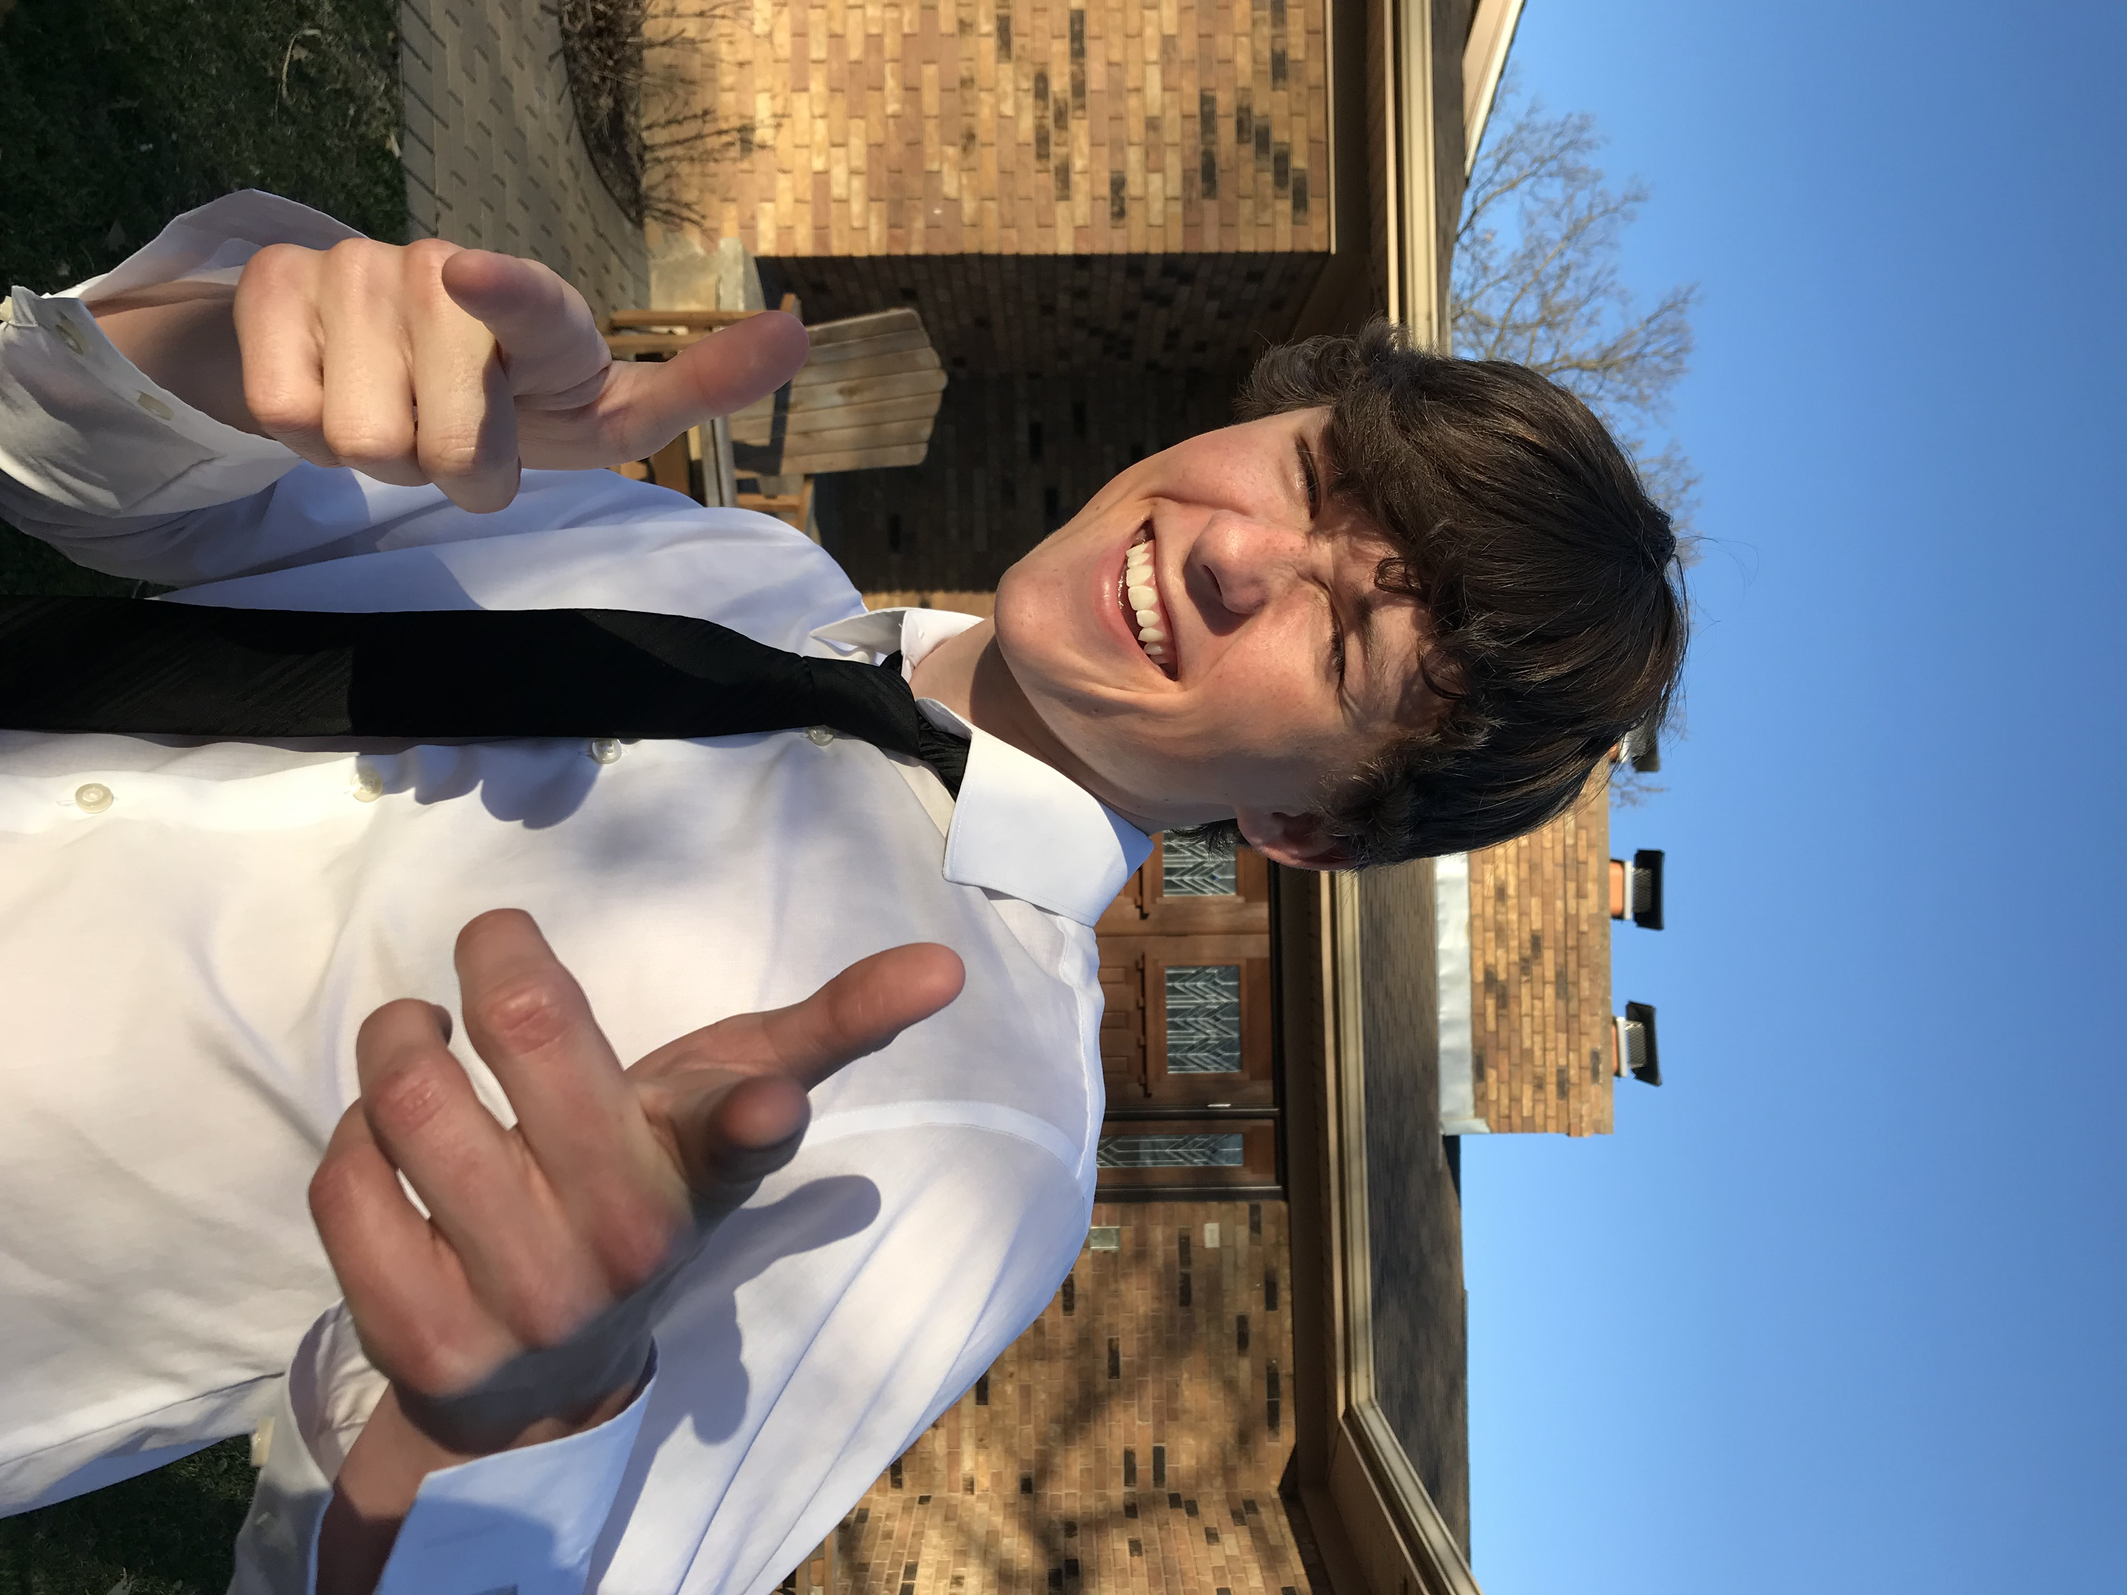
Mathsetter

Chase VanKlaveren

How does it feel to have earned the title Mathsetter?
Pretty freaking fantastic
What is the most fun you have had in a Math class?
Probably arguing with Eric this year.
Where plan to go to College:
University of Michigan
Do you plan to continue with math (directly or indirectly) in college?
My plan as it stands is to major in math, so yeah.
How many times have you laughed in class this year?
I think that I have laughed every day this year in BC. It is a very chill environment.
Do you have a favorite number?
4,000
What is your favorite song?
Counting Stars- One Republic
Person from the past that you would have most liked to meet?
Andrew Jackson because he was a Chad and I would like to learn a thing or two from him.
AP Calculus - Is it as intimidating as it sounds?
No, it’s not that intimidating. I guess you just should like Math.
Activities Involved in at School:
Golf, Tennis, Scholastic Bowl, Link Crew, Student Council
Favorite Movie and/or Book:
Speed Racer is a timeless masterpiece of cinema. My favorite book is Red Rising
Favorite Fictional Character:
Pikachu
What is your favorite place to do your homework? Why?
My room because it is secluded and I can blast my music.
What is the most recent search item you have attempted?
Is a hotdog a sandwich?
Favorite food or place to eat:
My favorite is sushi, so I like anywhere that has quality sushi.
If you could be a super hero, who would it be and why?
If I had to choose one, I would be Batman. He is just a normal man who has a lot of money and is
willing to do what is right.
What is your favorite hobby, why?
Playing video games, because I can mess around with the boys.
What is your favorite gift you have received or given?
My Nintendo Ds will probably be my favorite gift forever.
Best piece of advice you have heard in school?
Don’t procrastinate. I wish I could just learn it.
What is your favorite non-perishable food item?
Canned Pineapple
What is your favorite equation or formula?
The Pythagorean Theorem because it is used to often and in different ways.
What is your opinion on technology? Good or Bad?
Technology is good because it is what separates us from the monkeys.
What is your favorite word in the English (or any) language?
Bruh
What is your favorite kind of weather?
70 degrees, a little breezy
Any advice you would give to students who have to have Mr. C for a teacher?
I hope you like rock music.
Which came first the chicken or the egg?
The egg came first because the contents of the egg would mutate to create the chicken.
If you were an alien, what planet do you think you would come from?
I would come from a planet where only cool people are allowed.
What is your preferred method of tying your shoes?
The normal way
If you could choose, which decade would you like to have been born in?
I would choose the 2000’s because I enjoyed my childhood quite a lot.
What is your favorite joke?
Any “Your mom” joke
What is your favorite time of the day?
Noon.
What is your favorite article of clothing?
Jackets
Does math come easy to you, or do you have to work at it?
It has come easy to me until BC. This year I have to really work at it.
How many times have you dropped your calculator in class?
0
What is your LEAST favorite color?
Brown

