Mathsetter
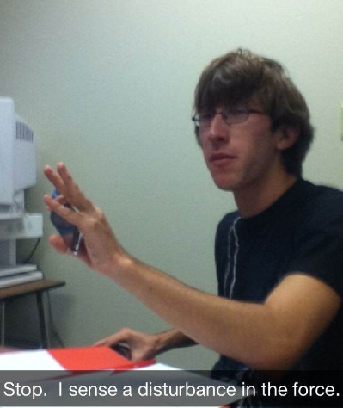

Mitchell Lamb
How does it feel to have earned the title Mathsetter?
Like being showered upon with the burning intensity of a thousand dying stars
What is the most fun you have had in a Math class?
Watching Mr. Kiss's rendition of various sports with his ruler as well as other Kiss related shenanigans
Where plan to go to College:
Northern Illinois University
Do you plan to continue with math (directly or indirectly) in college?
I am planning on majoring in physics so I will be using math extensively
Any advice you would give to students who have to have Mr. C for a teacher for two years?
Run
Do you have a favorite number?
19
Favorite Song:
“Never gonna give you up” by Rick Astley
Person from the past that you would have most liked to meet?
Either Albert Einstein or Marie Curie
Does math come easy to you, or do you have to work at it?
A combination of both
AP Calculus BC - Is it as intimidating as it sounds?
Yes, for me the first few letters of the alphabet have always filled my heart with terror and agony
Activities Involved in at School:
Cross-Country, Track, Scholastic Bowl, and Robotics
Favorite Movie or Book:
Movie- Shawshank Redemption Book- A brief history of time by Stephen Hawking
Favorite Fictional Character:
Saul Goodman
Best piece of advice you have heard in school?
“ Take calculus”, they said “ it'll be fun” they said
Which is your favorite toe?
I hold all my toes in equal regard
Favorite food or place to eat:
Chinese
What is your 5th LEAST favorite color?
Atomic Tangerine
Favorite Hobby:
reddit
If you were a janitor, what would be the least fun thing or place to clean?
Mr. C's classroom
How many times have you dropped your calculator in class?
Too many
Is there anything else you would like to share?
Nathan's head is really fuzzy

