Mathsetter
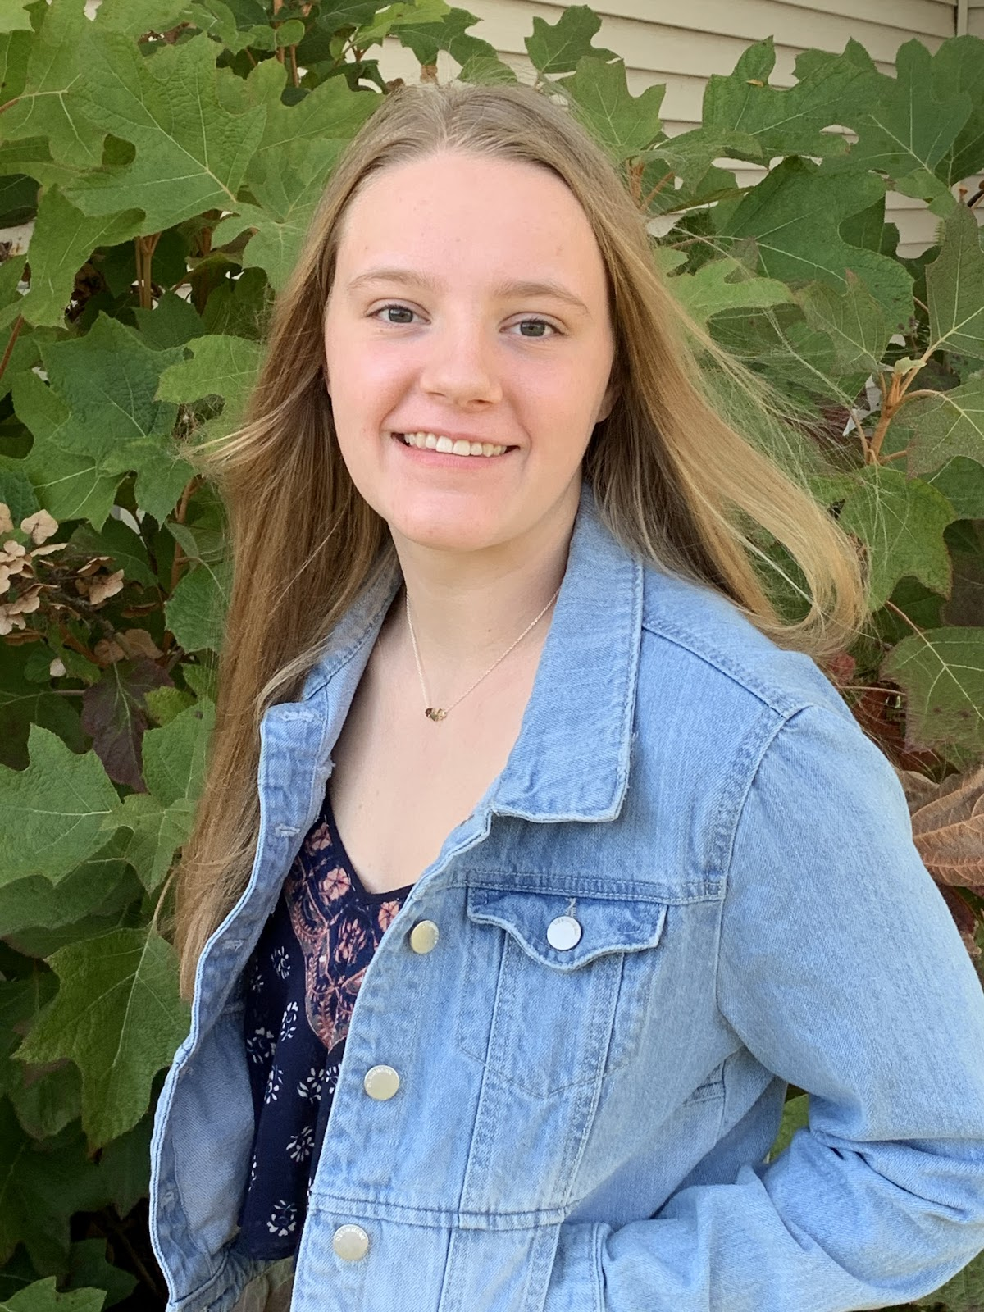

Melani Hodge
How does it feel to have earned the title Mathsetter?
This has been a dream of mine ever since my first day of kindergarten when my teacher asked me what
one plus one equaled.
What is the most fun you have had in a Math class?
Doing a take home calc test while my friend runs a red light with my car.
Where do you plan to go to College:
United States Air Force Academy (SPACE FORCE).
Person from the past that you would have most liked to meet?
Katherine Johnson.
Does math come easy to you, or do you have to work at it?
Easy: Math is like a box of chocolates… you ALWAYS know what you’re gonna get.
Do you plan to continue with math (directly or indirectly) in college?
Yes! I cannot imagine a life without math!
Any story you would like to share about one of your classmates?
One day when we were finished doing our math homework and had about ten minutes left before we
would go to our next class, Emma Dunker had shown me a video of a person jumping on an exercise ball
in order to do a flip at the beach. While he was jumping on the exercise ball, it completely disappeared. I
always thought that the ball had just popped, but she thought the ball got pushed deeper into the sand.
When she told me her theory, I couldn’t stop laughing because I thought her theory was completely
outrageous. I actually started crying because I was laughing so hard. But to this day, we still don’t know
what happened to that ball.
How many times have you laughed in class this year?
I have probably laughed at every single math class this year thanks to Emma Dunker, Tricia Elden, and
Olivia Mosbarger. They make math class fly by a little too fast.
What is your favorite song?
As of right now, “Drops of Jupiter” by Train.
Activities Involved in at School:
Geneseo High School Gymnastics Team and Swim Team.
Favorite Movie and/or Book:
Interstellar.
What is your preferred method of tying your shoes?
The “Loop de Loop” from SpongeBob.
What is your favorite equation or formula?
(it's that easy).
What is your favorite word in the English (or any) language?
Yes.
What is your favorite kind of weather?
Definitely not f-5 tornados.
What is your favorite gift you have received or given?
The gift of life.
If you were an alien, what planet do you think you would come from?
Planet X.
If you could be a super hero, who would it be and why?
Iron Man because he is super smart and super rich.
Best piece of advice you have heard in school?
“Study smarter, not harder.”
Which came first the chicken or the egg?
When you plug chicken and egg into the quadratic equation, x is omelet.

What is your favorite joke?
Yesterday I saw a guy spill all his Scrabble letters on the road… I asked him,
“What’s the word on the street?”
Favorite Fictional Character:
SpongeBob.
Any advice you would give to students who have to have Mr. C for a teacher?
The answers are in the back of the book.
What is your favorite hobby, why?
My favorite hobby is gymnastics. I like the physical challenge it offers me, and
I like how it keeps me active.
How many times have you dropped your calculator in class?
None that you know of.
What is your favorite non-perishable food item?
Honey.
What is your favorite article of clothing?
Adidas Sweatpants.
What is your opinion on technology? Good or Bad?
Good.
If you could choose, which decade would you like to have been born in?
Now.
AP Calculus BC - Is it as intimidating as it sounds?
Not really. I like to think of it as every other math class I have ever taken, but it just has an
AP in front of the name.
What is your favorite place to do your homework? Why?
Homework?
What is the most recent search item you have attempted?
“What is homework?”
Favorite food or place to eat:
Longhorn Steakhouse.
What is your LEAST favorite color?
Orange.
What is your favorite time of the day?
When I do gymnastics.
Do you have a favorite number?
9.
Is there anything else you would like to share?
I made my mom laugh a lot while answering these questions.

